Alerts / Live Social Data Streams

# How is this useful?

* Can be used by CFS or other agencies to compile and aggregate live official data of location and number of incidents for various events.
* Getting live commentary of official feeds in the once place to better plan and coordinate efforts amongst areas and groups
* Getting live commentary of unofficial feeds (the public) with text analysis to determine if there is a critical event or concerns happening in a certain area, potentially raising an alert for investigation before any official incident was raised.
  + In the event of natural disaster could feed in faster than waiting for a large number of calls to be taken, recorded and logged. This would be a live, as it’s happening stream of people’s posts. Potentially with new unknown information from people in the affected area.
* Can map a layer of official and unofficial incidents / posts to see where there is a high concentration of events

# How does this link in to the other data sets and location?

* Match official dataset message content to GNAF location data to get geo location of incident / event
* Match unofficial dataset posted location to GNAF location data to get the geo location of where a member of the public posted a certain event. To know what is happening and being detected/noticed in a certain area.
  + This can be used to filter out commentary from outside spectators and just trending chat on social media to first hand witnesses.

# Architecture

## Overview

* Twitter Stream / Twitter Firehose
* Logic Apps
* Cognitive Services (AI / Machine Learning)
  + Text Analysis
  + Sentiment Analysis
* Database, Cosmos DB, BLOB, Stream Analytics
* Statistical Data (Frequency, Volume, Location, Key Tags)

<https://docs.microsoft.com/en-us/azure/connectors/connectors-create-api-twitter>

<https://docs.microsoft.com/en-us/connectors/twitterconnector/>

<https://developer.twitter.com/en/docs/geo/places-near-location/api-reference/get-geo-search.html>

## Azure Resource Group

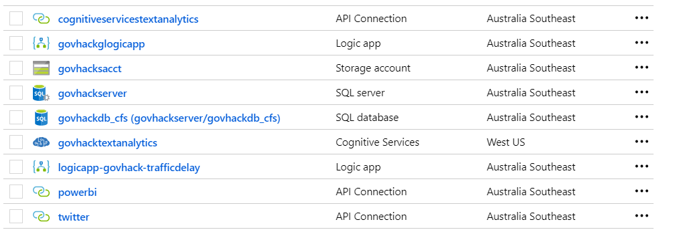

## Logic App – Twitter Streaming and Sentiment Analysis

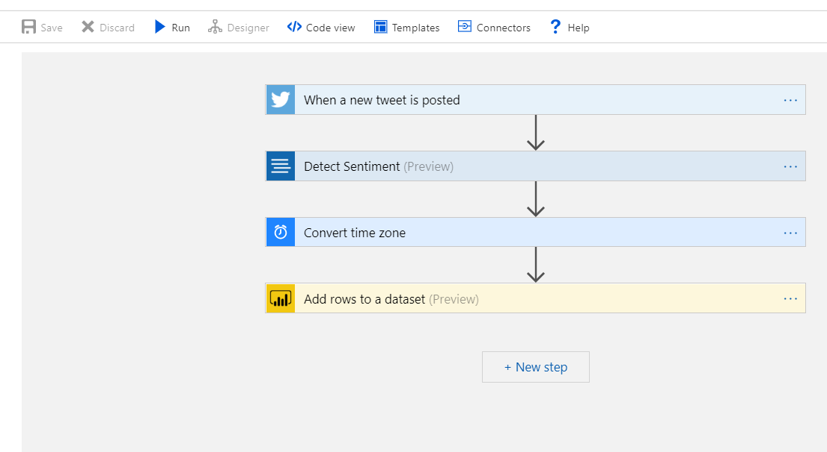

## Power BI Dashboard

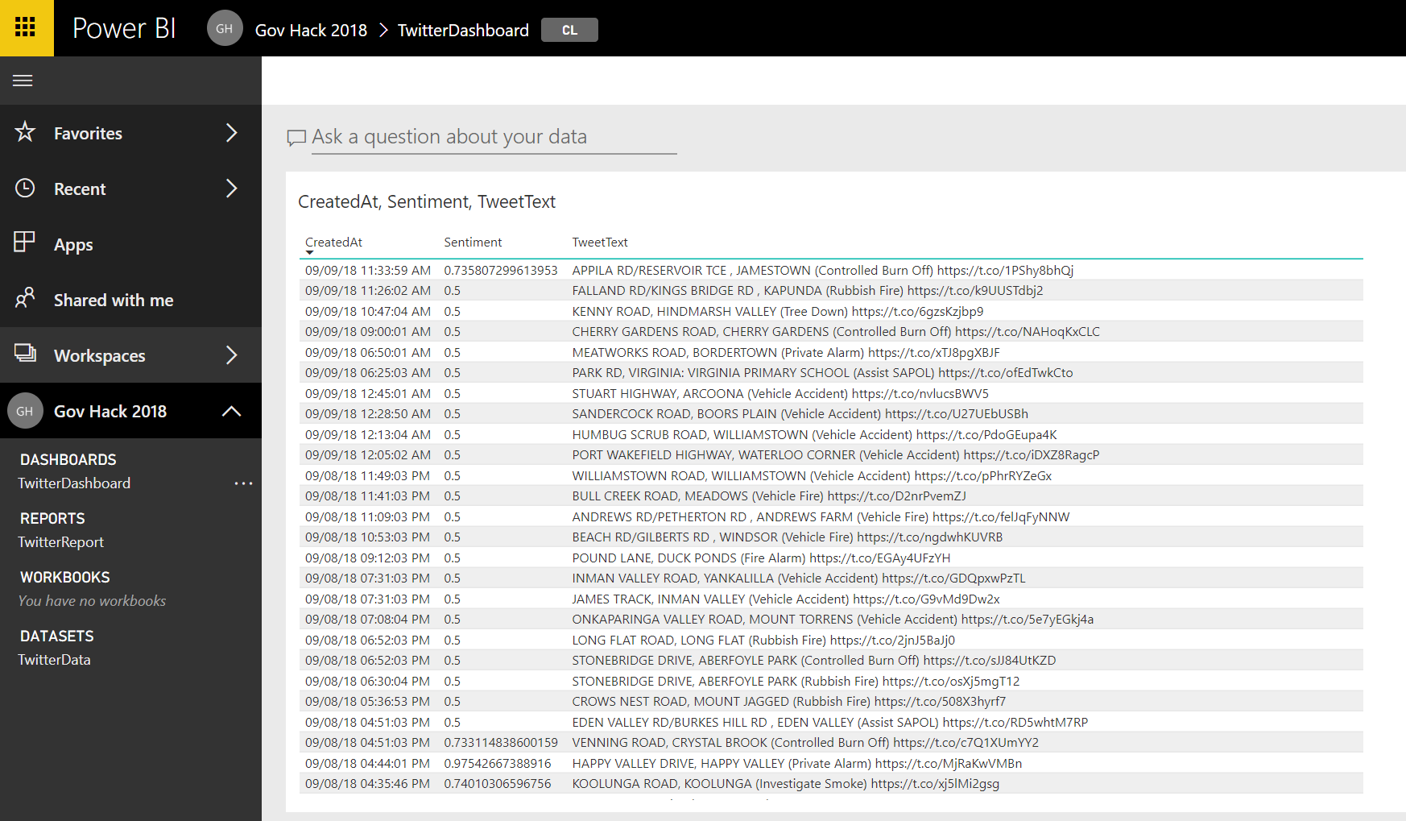

# Sources

## Official Feeds

* Twitter
  + @CFSAlerts
  + @SAPoliceNews
  + @AusFedPolice
  + @SA_SES
  + @EMERGCONTROL
  + @SA_Ambulance
  + @DeptDefence
  + @AustralianArmy
  + @Australian_Navy
  + @Australian_AirForce
  + …etc
* Facebook
  + SA Country Fire Service
  + CFSUpdates
  + …etc

## Unofficial Feeds

* Twitter
  + #Fire #Help #Emergency #Bushfire etc… in combination with #SA #Australia etc or using locational data from post